BACKGROUND:
During Dimpling of the Vertical Stabiliser one of the holes midway up the aft edge of the right hand side of the Vertical Stabiliser became elongated after the dimple die was actuated while not properly set.

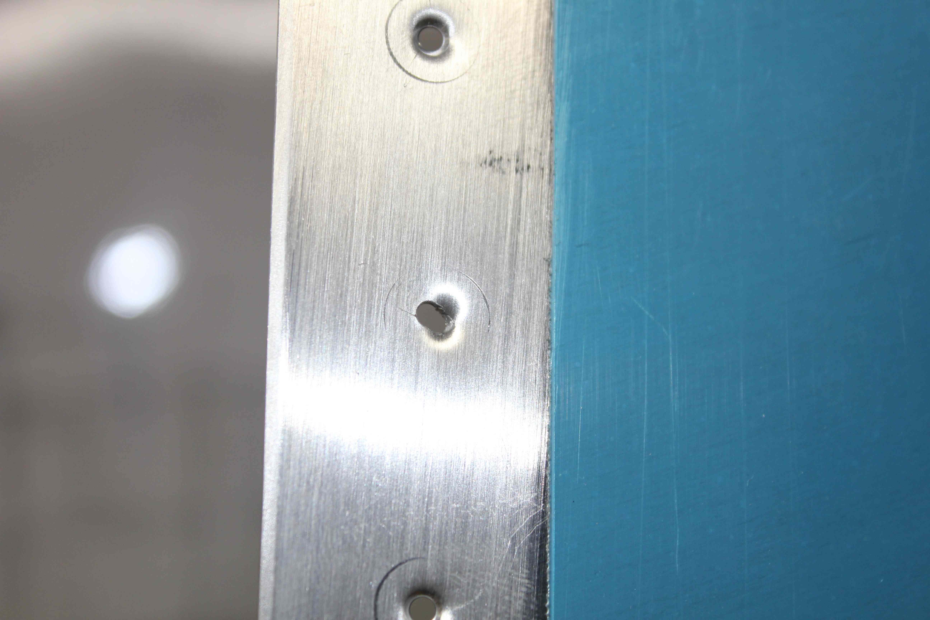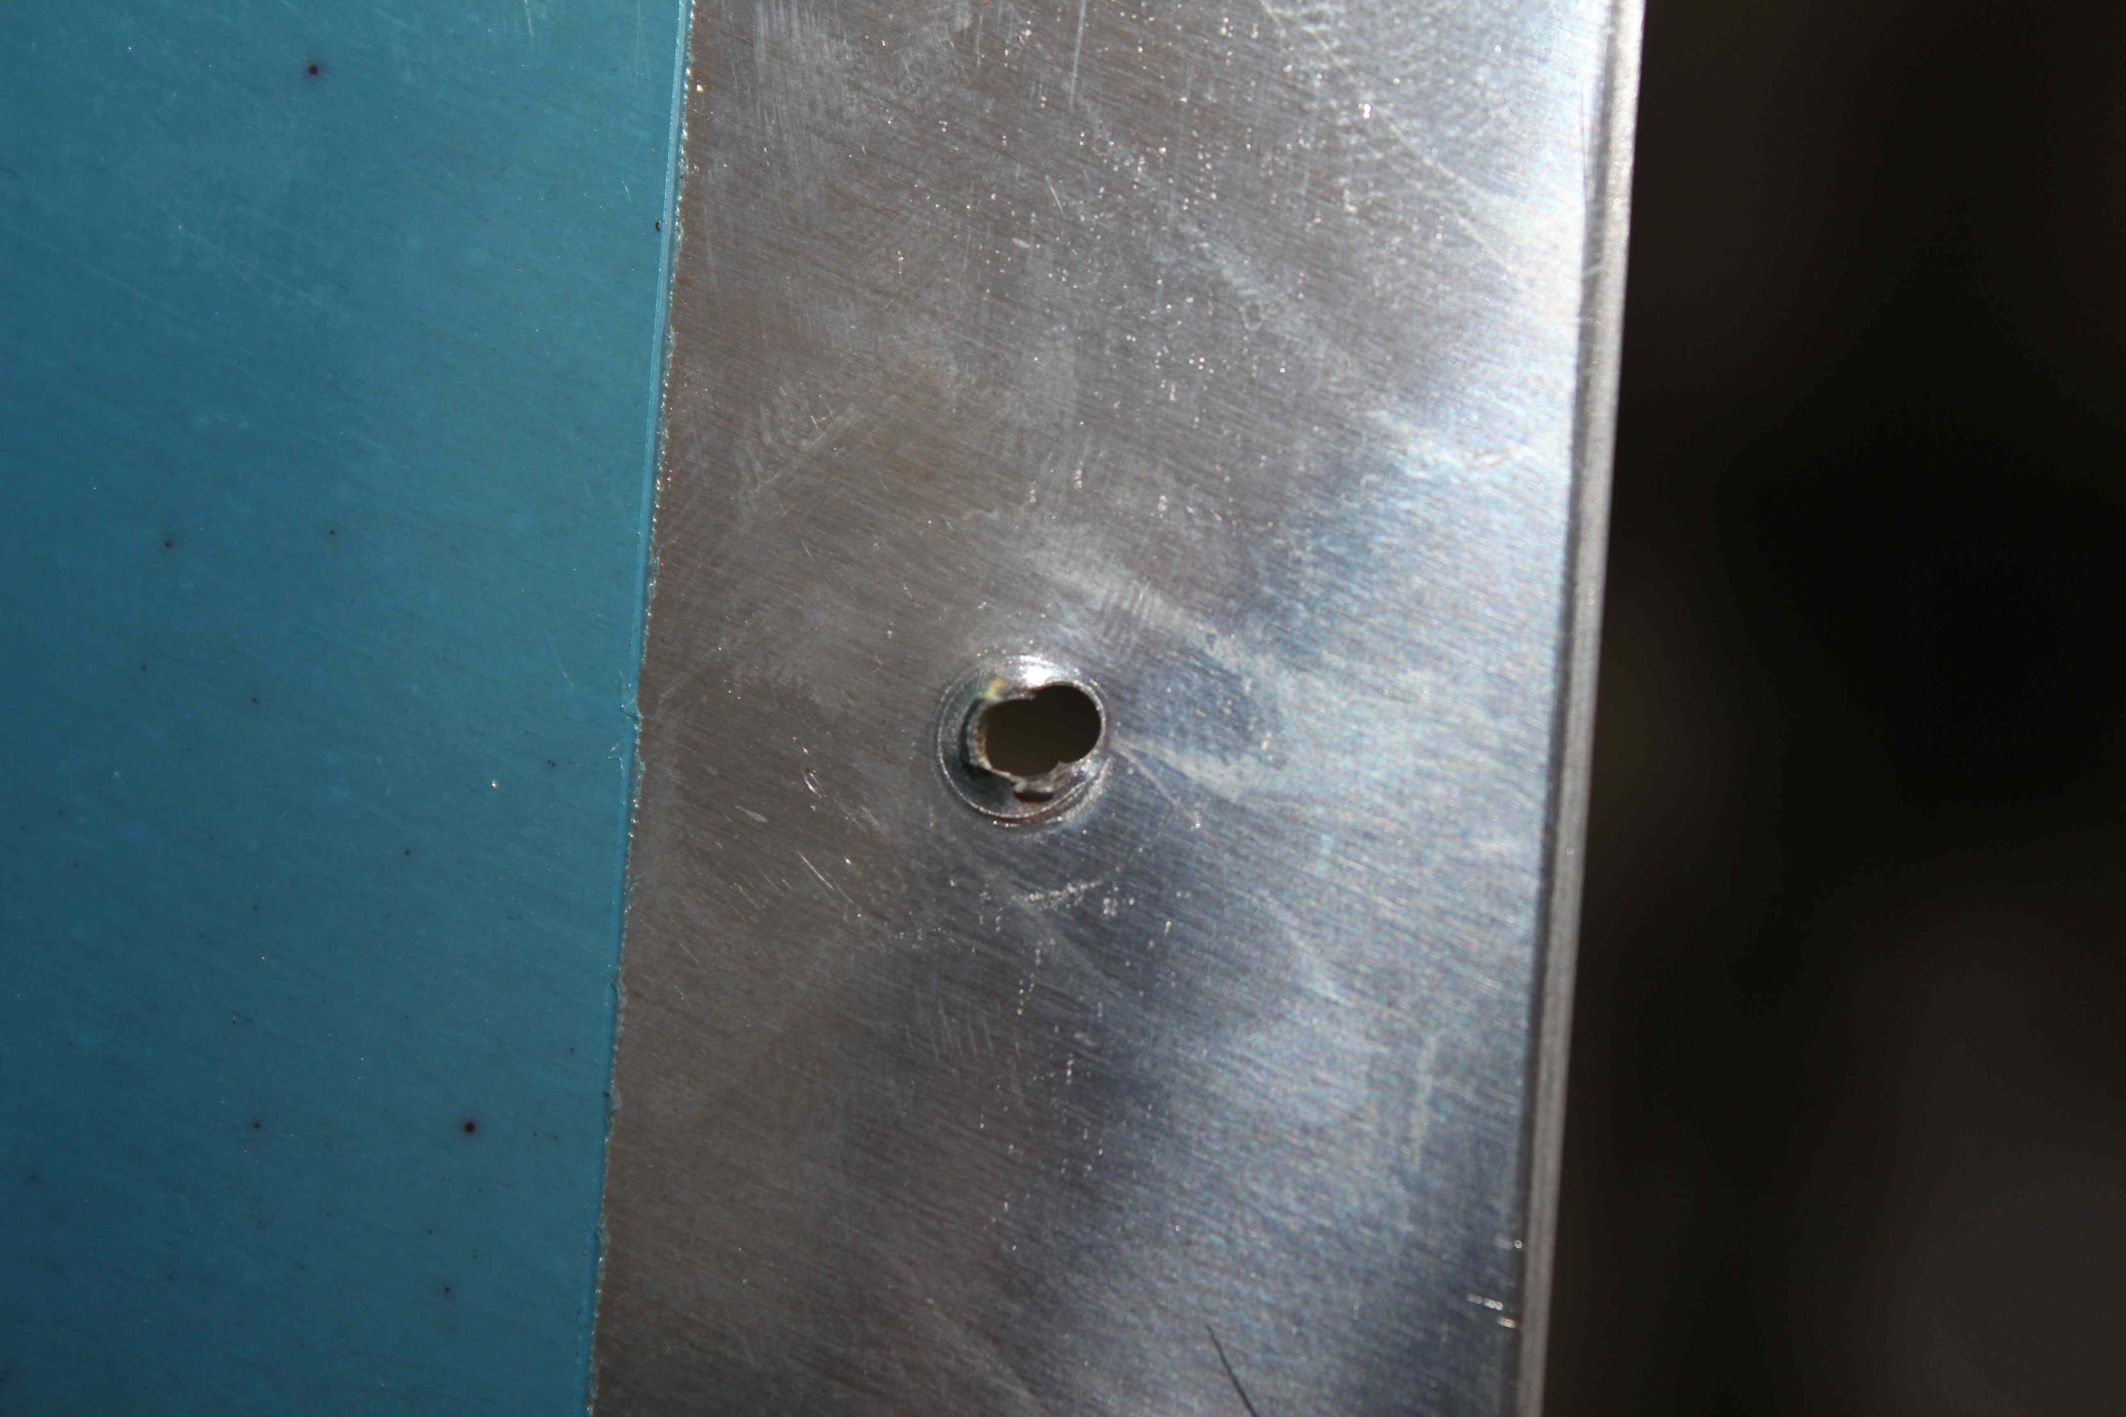

ACTION TAKEN:
Van’s Aircraft Technical Support were contacted and advised to:
“go to the next size rivet up to fill this slightly larger hole, also an oops rivet can be used in small quantities when building.”

From: "Sterling " <support@vansaircraft.com>
Subject: Re: Builder 73918 Dimpling problems
Date: 16 June 2012 1:07:18 AM AEST
To: Taran Laval <taranlaval@allboutaircraft.com>

In some cases like your top picture it may work to go to the next size rivet up to fill this slightly larger hole, also an oops rivet can be used in small quantities when building. For the figure eight hole where you almost completely missed the actual hole you can try flattening out the miss dimple and just going on like normal. I have heard of people filling the void with "JB" weld to give it a little added structure. A nother option is to abaddon that hole and put two new ones in, one to ether side of the one you skip. If you are worried about structural integrity or just don't want people to see an extra dimple in the middle of no where there is always the option of new parts.

Sterling

"Oops rivets"
These rivets are used to replace drilled out rivets where the hole may have been oversized. Typically the head on these rivets is smaller than the normal AN426 rivet, so an oversized AD3 hole can be opened to an AD4 size and the head will be similar to the original rivet.

On 15 Jun 2012 at 16:57, Taran Laval wrote:

>
> Hi Mate, Builder 73918 here,
> while dimpling today my finger got a little eager on the Vertical Stabiliser skin with the pneumatic
> squeezer twice and i've elongated two holes,
> what should I do?
> Thanks
> Taran
> Builder 73918
> Sydney, Australia
>

